APPLICATION FORM AS APPROVED TRAINING COURSE

(Please submit one form for each course to be approved by the Certification Board)

Name of Course Organizer:
Title of Course:
Admission Requirements, if any:
Level:
Course Objectives:
Breakdown of contents | Teaching topic |  | Duration
Total contact hours: |  | Evening ( ) / Saturday ( )  /weekday ( )
Assessment: | (a) Assessment Method(s) and Weighting:
Assessment: | ( %);
Assessment: | ( %); and
Assessment: | ( %).
Assessment: | (b) Overall Passing Mark:
Attendance Requirement:
Maximum class size
Minimum class size for course to be held

Instructor appointment criteria | (a) Education qualification(s):
Instructor appointment criteria | AND / OR;  (b) Professional qualification(s):
Instructor appointment criteria | AND / OR;  (b) Year of auditing experience:
Instructor appointment criteria | AND / OR;  (d) Year of training experience:
Total tuition fees (excluding the administration fee of HKICA) | HK$
Expected first commencement date (new course)
Year of delivering the course
Tentative schedule (on annual basis)
Approved Training establishment:
System of control of records/documents/
evaluation
Any certification or approval from another Training Certification Association? |  |  | No □ Yes □
Name of Training Certification Association, if yes:
First certification/approval date:
Authorized contact: |  | Position:
Signature: |  | Date:

FOR SECRETARIAT USE ONLY:
 | Fulfill syllabus and duration |  | Document review □ |  | On-site □ |  | Yes □ | No □
 | Qualification of trainer |  | Document review □ |  | On-site □ |  | Yes □ | No □
 | Performance of trainer |  | Document review □ |  | On-site □ |  | Yes □ | No □
 | Exercise and case study |  | Document review □ |  | On-site □ |  | Yes □ | No □
 | Assessment mode and questions |  | Document review □ |  | On-site □ |  | Yes □ | No □
 | RECOMMENDATION
 | Overall comments: ___________________________________________________________________________
 | ____________________________________________________________________________
 | ____________________________________________________________________________
 | ____________________________________________________________________________
 | Training course is recommended to be approved |  |  |  |  | Yes □ |  | No □
 |  | Team Leader: |  | Signature :
 |  | Other team member: |  | Signature :

主辦機構
Organised by
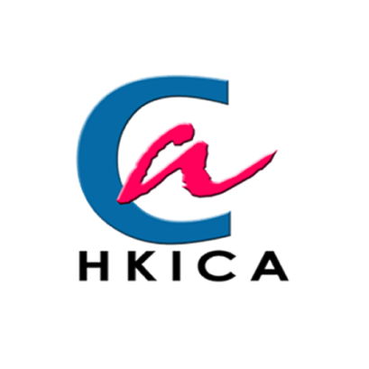 | Hong Kong Institution of Certified Auditors  香港专业审核师学会
" Any opinions, findings, conclusions or recommendations expressed in this material/event (or by members of the Project team) do not reflect the views of the Government of the Hong Kong Special Administrative Region, Trade and Industry Department or the Vetting Committee for the SME Development Fund and the Dedicated Fund on Branding, Upgrading and Domestic Sales (Organisation Support Programme). "
“在此刊物上／活动内（或项目小组成员）表达的任何意见、研究成果、结论或建议，并不代表香港特别行政区政府、工业贸易署及中小企业发展支援基金及发展品牌、升级转型及拓展内销市场的专项基金机构支持计划评审委员会的观点。”
「中小企业发展支援基金」拨款支助  Funded by SME Development Fund |  |  | 工业贸易署  Trade and Industry Department

